

**CGEPS Inaugural Research Grant**

**FINAL REPORT**

### Gender-sensitive training for safe and inclusive communities: A pilot for transformative placemaking in the public sector

FEBRUARY 28, 2022

This research took place on the lands of First Nations people across Victoria and we acknowledge them as Traditional Owners and Custodians of the lands and waters upon which we depend.

We recognise their continuing connection to land, waters and culture and we pay our respects to Elders past, present and emerging. In particular, the XYX Lab team would like to acknowledge the peoples of the Kulin Nation on whose land we work.

*Gender-sensitive training for safe and inclusive communities:*

*A pilot for transformative placemaking in the public sector*

This report forms part of:

The research project funded by the Commission for Gender Equality in the Public Sector.

Completed by Monash University Faculty of Art, Design and Architecture, and the Monash University XYX Lab. <https://www.monash.edu/mada/research/xyx>

For any questions regarding the contents of this report, please contact Nicole Kalms: [nicole.kalms@monash.edu](mailto:nicole.kalms@monash.edu).

###### Funding

We acknowledge the funding provided by the Lord Mayor’s Charitable Foundation, and the ongoing administration, guidance, and expertise from Monash University.

###### Ethics approval

Approval for this research project was granted by Monash Uni Human Research Ethics Committee (MUHREC) (17576)

The research team would like to acknowledge the kindness and motivation of the individuals and organisations who so willingly offered to participate and provide feedback on findings through expert panel sessions.

The following LGAs participated in the expert sessions:

* Banyule City Council
* Ballarat City Council
* Moreland City Council
* Port Phillip City Council
* Warrnambool City Council
* Casey City Council
* Hume City Council
* Monash City Council
* Geelong City Council
* Yarra City Council
* Latrobe City Council
* Monash City Council
* Kingston City Council

# CONTENTS

**Executive Summary** **4**

**Introduction and Background** **6**

**Summary of Training Module** **7**

**Course Structure** **8**

**Overview of Modules** **8**

**Assessment** **9**

**Target Audience, Enrolment & Designated CGEPS Places** **1****0**

**A Summary of Relevant Literature** **1****1**

**Common Certification Scripts** **1****4**

**APPENDICES** **1****5**

Appendix A - Expert Panel Sessions 16

Appendix B - Ethics 20

# Monash University Research Team

|  |  |  |  |  |
| --- | --- | --- | --- | --- |
| **#** | **Full name** | **Position** | **Organisation** | **Role on Team** |
| 1 | Ass/Prof Nicole Kalms | Founding director, XYX Lab | Monash University | Lead CI |
| 2 | Ass/Prof Gene Bawden | Head of design, Co-Director, XYX Lab | Monash University | Designer |
| 3 | Dr Jess Berry | Researcher, XYX Lab | Monash University | Researcher |
| 4 | Dr Gill Matthewson | Researcher, XYX Lab | Monash University | Researcher |
| 5 | Isabella Webb | Spatial designer, XYX Lab | Monash University | Research Oﬃcer |

If you have any queries concerning the project, please contact Associate Professor Nicole Kalms: [nicole.kalms@monash.edu](mailto:nicole.kalms@monash.edu)

# EXECUTIVE SUMMARY

This research report is focused on *Gender-sensitive training for safe and inclusive communities:*

*A pilot for transformative placemaking in the public sector* project*.* The research project has expanded the knowledge and evidence base supporting the Gender Equality Act 2020 (Vic) and its implementation through the development of an online training program for public sector organisations across Victoria. Working with thirteen local government organisations, the course aims to support local councils to meet their obligations under the Gender Equality Act 2020.

The research undertaken for this project confirms that all genders are impacted by stereotypes and power dynamics. Long-term research exposing how gender inequity has a significant detrimental impact on women, girls and gender-diverse people. Consideration of gender is a neglected factor in the equitable planning, design, distribution and delivery of public spaces and services in Victoria, with a noticeable gap in support structures for the public sector in light of the requirements of the Gender Equality Act and associated reporting. While the focus of this course is on women, research indicates that better cities for women creates better cities and communities for everyone.

The research found that the course *Gender-Sensitive Training for Inclusive Placemaking* will help those in the Victorian public sector – and beyond – address the relationship between the built environment and gender inequity.

While there are no quick fix solutions to gender inequity, the expert panel strongly affirmed that the course will ensure that people tasked with designing, planning and imagining cities and communities are strong advocates for gender-sensitive placemaking. Advocacy means they have heightened capacity to interrupt the gendered stereotypes of both material space and the behaviours that take place within it.

By charging participants with gender-sensitive knowledge and by forging new insights into the urban environments in which they work, public sector organisations can better understand how their communities and places are shaped by gender. In order to address spatial inequities, the expert panel agreed that various patterns of discrimination need to be drawn out and challenged. They also agreed that the course content would be well-placed to shift the bias in the built environment profession.

**Key recommendations**

* Public spaces and infrastructure must meet the needs of the whole community and is a priority for Victorian LGAs and the public sector more broadly. This includes a holistic approach to community building and place-based work;
* Strong and clear leadership is critical to inclusive placemaking. Setting the direction requires leadership within state and local government and public recognition of the unique experiences of women;
* Increasing the understanding of a gender lens will also increase public sector organisations understanding of gender equality;
* Prioritise women’s diverse uses and experiences of public placemaking in the planning and design process;
* Support online and asynchronous learning for individuals, teams and organisations to develop skills in gender-sensitive and inclusive placemaking;
* Education and awareness through the implementation of *Gender-Sensitive Training for Inclusive Placemaking* will support primary prevention of gender-based violence in public space.

**Summary of findings**

* The public sector expert panel commended:
  + the practical and multi-strategy tools of the course;
  + the approach to teaching people to ‘walk in the shoes’ of some of the most disadvantaged areas and not plan ‘business as usual’ from a purely technical point of view;
  + creating advocates for gender equality in relation to placemaking is vital;
  + a course which encourages the opportunity for reflection;
  + applying a gender lens across a broad council cohort;
  + the commitment to better design of safe spaces for women AND meeting Gender Equality Act requirements in applying Gender Impact Assessments;
  + the use of live projects with realistic opportunities to implement change is a huge benefit because it provides value to teams signing up to this training – and further builds capacity around people’s understanding.
* The public sector expressed that the course would benefit organisations by:
  + empowering all areas of the public sector to use a gender lens (ie. including urban design, open space, lighting teams) will help the public sector to meet the GIA requirements and the needs of our community;
  + making the gender-sensitive design lens the norm, disrupting the status-quo design and /or design thinking process;
  + strengthening gender equity by ensuring a multi-strategy approach is taken particularly with safety for women and gender-diverse people;
  + providing the ability for employees in the public sector to undertake and lead process without input from GE lead;
  + cross-council teams involved in public space planning and design have the opportunity to work collaboratively through the course.

# INTRODUCTION AND BACKGROUND

*Gender-sensitive training for safe and inclusive communities: A pilot for transformative placemaking in the public sector* supports the expansion of research knowledge and develops the evidence base underpinning the Gender Equality Act 2020 (Vic) and its implementation. This report provides an overview of the activities to date in developing a pilot for an online, interactive training module for public sector organisations across Victoria to train staff. The training is designed to develop staff awareness of gender-sensitive approaches to mitigate against discrimination and exclusion in public space, thus supporting local councils to meet their obligations under the Act.

Gender-sensitive training across the Victorian public sector is essential to improving the safety of women in cities and towns. Consistently working to understand what women’s safety means in urban spaces needs to be supported by direct training to develop staff awareness of gender-sensitive approaches that will mitigate against discrimination and exclusion in public space. This course introduces the fundamental tenets of gender-sensitive placemaking and prime participants to advocate for women’s safety in urban placemaking with skills to mitigate against discrimination and exclusion in public space.

The research team completed the following tasks:

* Audit of existing XYX Lab research in Victorian contexts to collate strategies for designing gender-sensitive design approaches, including streets, parks, public transport and urban spaces;
* Collation of content for international best-practice approaches to intersectionality in gender-sensitive placemaking;
* Collation of online training material (delivered on Monash University platform as agreed);
* The delivery of the training overview to an expert panel, over three sessions for feedback from local government partners, including metro and regional councils.
* Preparation of online training material for Monash University platform (as agreed);

# SUMMARY OF TRAINING MODULE

The course engages participants in the fundamental tenets of Gender-Sensitive Placemaking. The training ensures that participants have competency in applying a gender lens in placemaking strategies within their organisation. Upon successfully completing the course, participants will have developed their capacity to advocate for gender-sensitive approaches in their organisation/sector. The course focuses on increasing gender-sensitive competency, directing participants to best practice approaches and developing advocates for gender-sensitive placemaking in the public sector.

The aims of the course are for participants to:

* Understand the importance of gender-inclusive and safety theories, frameworks, and research in evaluating and designing Gender-Sensitive Placemaking projects.
* Have developed an informed gender lens and the capability to apply that gender lens to their own work-role using reflective practice.
* Support and advocate from a knowledge-based position for gender-sensitive placemaking within the workplace, particularly as it relates to policy and practices and engagement with internal and external stakeholders.
* Be able to confidently undertake informed and gender-sensitive design of policy, urban spaces, or programs.

The course developed by the Monash University XYX Lab recognises women are not a homogenous group and represent enormous diversity in their cultural background, socioeconomic status, where they live, their sexuality, disability and age. Guided by the feedback from the expert panel members, the term ‘women’ is inclusive of all women, including cis-women, trans-women and intersex women. The course is additionally framed through an intersectional approach: meaning participants will also be required to demonstrate an understanding of how addressing gender inequity intersects with other oppression, such as race, ethnicity, age, ability, indigeneity and sexuality. Guided by Kimberlé Crenshaw[1], the micro-credential will examine – at a level commensurate with the credential – how discrimination and oppression intersect and lead to different experiences of oppression for women.

# COURSE STRUCTURE

*Gender-sensitive training for safe and inclusive communities: A pilot for transformative placemaking in the public sector* is proposed as asynchronous training where the Monash University XYX Lab are the instructors, and the learning path is set up so that students engage at their own pace with peer-to-peer learning reflections.

A one-on-one consultation with an XYX Lab expert will occur in week 5, focusing on weeks four and five activities and assessment submission.

The first three modules develop foundational knowledge for the participants. The final three modules allow for the application and testing of this knowledge in response to real-world projects and spaces. Participants are assessed through the curation of an advocacy ‘toolkit’ they develop to support their ongoing work in the public sector.

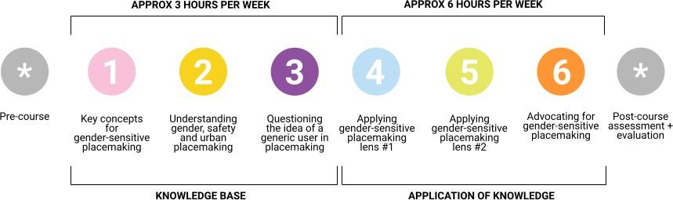

Figure 1 (above): Overview of modules for *Gender-sensitive training for safe and inclusive communities: A pilot for transformative placemaking in the public sector*

# OVERVIEW OF MODULES

Figure 1 outlines the course thematics and weekly module progression, with each week following a similar structure (Figure 2). Participants will be primed for weekly learning with a ‘read watch listen’ introduction. Two videos will delve into evidence-based research related to the corresponding weekly thematic. These will be pre-recorded by the XYX Lab team with visual aids. A quiz is designed to be a checkpoint. Encouraging participants to reﬂect on what they had just learned and consolidate any key points before participants progress on the activity. (See Appendix A for details of Module 1-6)

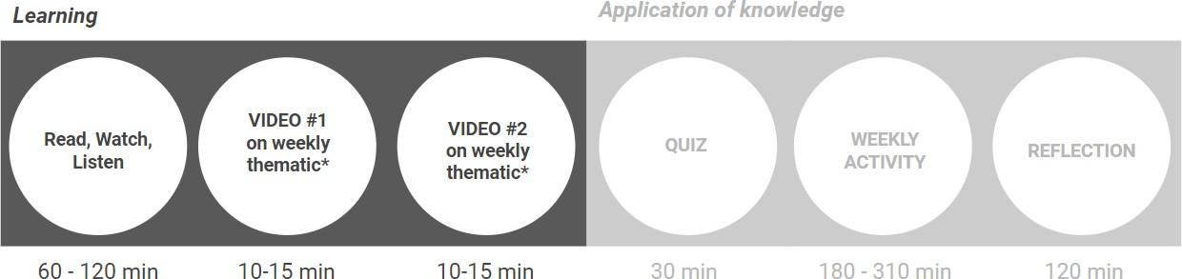

Figure 2 (above): Overview of weekly structure *Gender-sensitive training for safe and inclusive communities: A pilot for transformative placemaking in the public sector*

The online collaboration tool “Jamboard” will be used for activities (see Appendix C). Each activity is supported by step-by-step instructions and prompt ‘buttons’ to instruct participants on using the Jamboard for that week and any other necessary information to guide participants through the activity. Each set of weekly activities requires participants to complete a short reﬂection in the collective *Reﬂect, discuss, share* Jamboard.

Alongside the asynchronous learning, there will be opportunities for participants to reach out to the course coordinator via email. There will also be a mentoring session with one of the XYX Lab leadership team in week five. The XYX Lab will monitor emails daily and responses posted to the courses Moodle Forum, the Monash University learning platform.

Participants are supported by an annotated resource list with evidence-based research in the form of journal articles, reports and books. (see annotated bibliography on page 12)

# ASSESSMENT

The majority of activities will form part of the ﬁnal submission. Two assessments are required to complete the course successfully:

1. Project Journal and
2. Pecha Kucha-style presentation with a written strategic statement.

The Project Journal will produce a PDF folio that documents an understanding of the social issues faced by women and how the application of gender-sensitive placemaking strategies and evidence-based research can support advocacy within the public sector. It will include the outcomes of the weekly activities and all reﬂections. After consultation with experts in Module Five, the assessment period will allow participants to revisit and reﬁne work from the ﬁve previous modules.

Each participant will also develop and deliver a presentation alongside a strategic advocacy statement. The presentation will be delivered as a recording and asks participants to critically explore the process and application of gender-sensitive placemaking strategies for their chosen site.

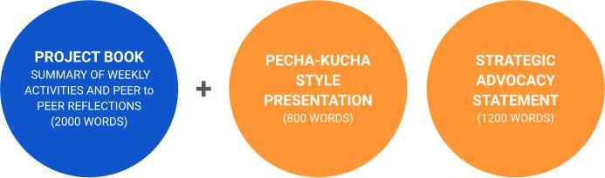

Figure 3 (above): Overview of assessments *Gender-sensitive training for safe and inclusive communities: A pilot for transformative placemaking in the public sector*

# TARGET AUDIENCE, ENROLMENT & DESIGNATED CGEPS PLACES

The target audience includes all employees of the public sector working in gender equality, urban design, infrastructure and community engagement. More broadly, designers and graduates of design and architecture and planning courses may want to undertake the course for professional development. Organisations may choose to register whole teams with a speciﬁc project focus in weeks four to six. There will be three places per session available for free access for CGEPS deﬁned entities.

Three scholarships per course will be allocated per session (up to 9 scholarships per year). The process for allocating those places will be facilitated by Monash University XYX in consultation with CGEPS.

# 

# A SUMMARY OF RELEVANT LITERATURE

**Annotated bibliography**

Below is an example of the extended resources provided. The annotated bibliography includes additional resources to the recommended weekly resources.

|  |  |  |  |  |
| --- | --- | --- | --- | --- |
| **Author** | **Title** | **Coding system** | **Summary** | **Where to find it** |
| Australian Institute of Health and Welfare. | *People with disability in Australia.* (2020) | Easy read – report format including graphs, stats, chapters, subheadings and hyperlinks to relevant resources  45 min read | This report brings together information from a range of national data sources to contribute to a greater understanding of disability in Australia. For example, some people with disabilities face challenges routinely and are more likely to experience poor health, discrimination and violence than those without disabilities. The report also highlights critical data gaps in disability research.  Suggested sections:  pp. 1-3: Summary of information and statistics of people living with disability in Australia;  pp. 8-29: Defining disability, the disability policy environment, prevalence of disability, and activities people need help with;  pp. 123-134: Justice and safety, and disability discrimination;  pp. 145-158: Violence against people with disability. | Open access: [LINK](https://www.aihw.gov.au/reports/disability/people-with-disability-in-australia/contents/about-this-report/defining-disability) |
| Beebeejaun, Yasminah. | *Gender, urban space, and the right to everyday life.* (2017) | Medium read – theory-driven academic article  20 min read | This article explores how the discourse of urban rights, such as ‘the right to the city’, has neglected a gender perspective. Although women face continuing economic and social marginalisation, their place in the city has not been adequately considered. The article suggests that a fuller recognition of the contested publics that coexist within the contemporary city and the gendered mediation of everyday experiences could enable planners and policymakers to undertake more inclusive forms of intervention in urban space. | Open access: [LINK](https://www.tandfonline.com/doi/full/10.1080/07352166.2016.1255526) |
| Committee for Sydney. | *Safety after dark: Creating a city for women living and working in Sydney.* (2019) | Easy read - report format includes graphs, tables and participant quotes.  45 min read | This report details research undertaken in Sydney over a six-week period in 2018 that aimed to understand women’s experiences of the city. Using an online mapping tool, women were encouraged to identify and share the location of public spaces that make them feel uneasy and scared or happy and safe and explain why. Analysis of over 2,700 pins revealed that sexual harassment was the main issue impacting women in Sydney at night. The behaviour of men and the physical conditions of a location also made a place unpleasant and affected perceptions of safety. The report outlines several key recommendations and highlights the need to engage women and girls as co-designers in designing and planning the city. | Open access: [LINK](https://www.monash.edu/mada/research/sydney-after-dark) |
| Cozens, Paul, Greg Saville and David Hillier.. | *Crime Prevention Through Environmental Design (CPTED): A Review and Modern Bibliography.* (2005) | Medium read –  25 min read | An overview of CPTED and its component parts, as well as a review of the core findings from past research on place-based crime prevention research.  Suggested pages: 3 - 11 | Open access:  [LINK](https://espace.curtin.edu.au/bitstream/handle/20.500.11937/19408/131503_CPTED-REVIEW-2005-prepublication.pdf?sequence=2) |
| Golan, Yael, Nancy Wilkinsonm, Jason M Henderson and Aiko Weverka. | *Gendered walkability: Building a daytime walkability index for women* | Medium read – theory-driven academic article  20 min read | Focusing on urban walkability in San Francisco, this article explores the following questions: What variables influence women’s propensity to walk? And, does the leading walkability index, Walk Score, reflect women’s walkability?  Through focus groups with local women, it was found that women ranked crime, homelessness and street cleanliness as the three most influential factors on walkability. The comparison between the Women's Walkability Index and the Walk Score Index revealed huge discrepancies, indicating that commonly accepted conventions about what promotes walking may be inaccurate when it comes to women users. | Open access: [LINK](https://www.jtlu.org/index.php/jtlu/article/view/1472) |
| Indigenous Architecture and Design Victoria (IADV), Design Institute of Australia (DIA) and  Deakin University Institute of Koorie Education (IKE), and School of Communication and Creative Arts (SCCA) | *Australian Indigenous*  *Design Charter - Communication Design*  *Protocols for Sharing Indigenous Knowledge in Communication Design Practice* | Easy read - ten-point charter  40 min read | This charter focuses on acurate andaims to help facilitate accurate and respectful representation of Australian Aboriginal and Torres Strait Islander culture in design and associated media.  The role of the Charter is to assist design practitioners, both Indigenous and non-indigenous. Designers can also use the Charter to promote understanding with their clients and the buyers of design including governments, corporations, businesses and not-for-profit organisations.  Despite the existence of protocols for the creation, distribution and ownership of Australian Aboriginal and Torres Strait Islander visual and media arts, there was, until the creation of the Charter, a lack of information, guidance and professional leadership regarding the appropriate creation and commercial use of Indigenous graphical representations in communication design practice. This cultural innovation tool responds directly to calls by governments, professional design associations, professional design practitioners and buyers of design to address the need for cultural guidance. | Open access: [LINK](https://www.design.org.au/documents/item/216) |
| Johnson, Molly and Ebony Bennett. | *Everyday sexism: Australian women’s experiences of street harassment.* (2015) | Easy read – report format includes graphs, tables and participant quotes  15 min read | Collating survey data and supporting research, this report reveals that nine in ten Australian women have experienced street harassment (87%) and modify their behaviour in public space in response to these experiences.The report outlines Australian women’s experiences of both non-physical street harassment and physical street harassment. In relation to this, 40% of Australian women do not feel safe when walking alone at night in their local area, compared to only 17% of men. | Open access: [LINK](https://australiainstitute.org.au/report/everyday-sexism/) |
| Kalms, Nicole. | *More lighting alone does not create safer cities: Look at what research with young women tells us.* (2019) | Easy read – accessible informed commentary  5 min read | This article discusses research that sought to understand the impact of lighting on women’s perceptions of safety. Analysing over 80 of the most unsafe “hotspots” identified by women in Melbourne, the research found that high illuminance – or very bright and overlit spaces – does not correlate with young women’s perceptions of urban safety. This suggests that more nuance is required in lighting strategies. The article highlights the need to develop urban strategies and planning policies that draw on women’s experience and expertise as users of city spaces. | Open access: [LINK](https://theconversation.com/more-lighting-alone-does-not-create-safer-cities-look-at-what-research-with-young-women-tells-us-113359) |
| Kalms, Nicole. | *To design safer parks for women, city planners must listen to their stories.* (2019) | Easy read – accessible informed commentary  5 min read | In this article, Kalms describes the benefits of using geo-locative mapping and methods of co-design to gather and understand women and girls’ experiences of public space to ensure gender mainstreaming of urban design. | Open access: [LINK](https://theconversation.com/to-design-safer-parks-for-women-city-planners-must-listen-to-their-stories-98317) |
| Lange, Alexandra. | *Teen Girls Need Better Public Spaces to Hang Out.* (2021) | Easy read – accessible informed commentary  10 min read | In this article, Lange explores the lack of urban space for teenage girls and outlines a number of projects designed with girls’ interests in mind. For instance, Swing Time by Höweler + Yoon Architecture was designed for groups to swing and stand around to have a conversation, and a playable street in London by MUF designed in consultation with youth groups. | Open access: [LINK](https://www.bloomberg.com/news/features/2021-05-28/we-need-more-public-space-for-teen-girls) |
| Latrobe University, Monash University XYX Lab and RMIT. | *TramLab Toolkits: Improving the safety of women and girls on Victorian public transport.* (2021) | Easy read – accessible guidelines  25 min read (Comms and Placemaking)  15 min read (Data and Training) | These toolkits provide practical gender-sensitive steps to help create safer public transport for girls and women. Toolkit 1 outlines steps for developing gender-sensitive communication campaigns. Toolkit 2 details the process for engaging gender-sensitive placemaking to enhance safety for women. Toolkit 3 details the steps for gathering gender-sensitive data for transport spaces. Toolkit 4 outlines the implementation of gender-sensitive training for public transport service providers and aligned security staff. | Open access: [LINK](https://www.monash.edu/mada/research/tram-lab) |
| Myers, Jess. | *How more security makes women and queer people feel less safe.* (2020) | Easy read - accessible informed commentary  15 min read | In this article, Jess Myers challenges traditional urban strategies of surveillance control and incarceration, instead advocating for a system of restorative justice in urban environments, where a broader range of community, design and healthcare workers work with women and gender diverse people to create safer communities. | Open access: [LINK](https://failedarchitecture.com/how-more-security-makes-women-and-queer-people-feel-less-safe/) |
| Plan International and XYX Lab. | *Unsafe in the city: Research into the everyday experiences of girls and young women.* (2018) | Easy read – report format includes graphs, tables and participant quotes  Summary: 5 min    Full report: 25 min read | Based on research conducted in Delhi, Kampala, Lime, Madrid and Sydney, Unsafe in the city illustrates the sexism, sexual harassment and abuse that girls and young women experience in public spaces. Despite sociocultural and geographical differences between each city, in none of the cities were young women’s experiences of urban life free from fear.  Three key recommendations are provided; change the behaviour of men and boys, increase girls’ participation in decision-making, and enforce laws and policies against sexual harassment. | Open access: [LINK](https://www.monash.edu/mada/research/safer-cities) |
| XYX Lab (Edited By Jess Berry, Timothy Moore, Nicole Kalms, Gene Bawden) | *Contentious Cities:*  *Design and the Gendered Production of Space* (2021) | 7-hour read, 266 Pages 74 B/W Illustrations | Contentious Cities offers unique interdisciplinary approaches to understanding gendered spatial equity in the urban environment. Positioning design as a central component in how cities produce, construct, represent and materialise gendered spatial practices, it brings together practice and theory to critique, question and enable solutions that challenge the root causes of gender inequalities in cities. Through a rich array of case-studies, practice-led interventions, and historical and theoretical perspectives, it examines important issues that affect the ways in which women, and people of diverse gender and sexual identities experience and participate in cities. | Paid access: [LINK](https://www.routledge.com/Contentious-Cities-Design-and-the-Gendered-Production-of-Space/Berry-Moore-Kalms-Bawden/p/book/9780367520199) |
| XYX Lab and ARUP. | *Lighting cities: Creating safer spaces for women and girls.* (2019) | Easy read – clear outline of finding with diagrams  3 min read | A brief outline of XYX Lab’s collaboration with ARUP and the importance of understanding the patterns that exclude women from public spaces, rather than deferring to usual responses of brighter lighting, more CCTV cameras and authority figures. | Open access: [LINK](https://www.monash.edu/mada/research/lighting-cities) |
| XYX Lab and Crowdspot. | *YourGround Victoria Report.* (2021) | Easy read – clear structure includes definitions of key terms, chapter summaries, and data visualisations  45 min read | The YourGround Victoria project is a social research project undertaken by XYX Lab and Crowdspot that mapped women and gender-diverse people’s perceptions of safety when exercising and recreating for health and wellbeing in Victoria’s public spaces.  The data was crowdsourced over a three-month period during 2021. The findings revealed that users perceive spaces differently depending on the activity being undertaken and spaces are rarely viewed as wholly safe or unsafe for all users at all times of the day. | Open access: [LINK](https://www.yourground.org/) |

# 



**APPENDICES**

**CGEPS Inaugural Research Grant**

# Appendix A - Expert Panel Sessions

Invited council staff undertook the expert panel sessions on Tuesday November 9, Wednesday November 10 and Thursday November 11. The feedback allowed the course to be refined. This appendix contains some of the un-synthesised transcripts and feedback from the expert panel sessions.

The LGA’s invited to attend the expert panel sessions included (those HIGHLIGHTED participated in at least one session:

|  |  |  |
| --- | --- | --- |
| **SESSION ONE** | **SESSION TWO** | **SESSION THREE** |
| Banyule City Council Ballarat City Council Moreland City Council Port Phillip City Council Warrnambool City Council Casey City Council  Hume City Council | Monash City Council Geelong City Council Hume City Council Ballarat City Council Port Phillip City Council Banyule City Council  Warrnambool City Council | Yarra City Council Latrobe City Council Monash City Council Kingston City Council Banyule City Council |
| Metro Melbourne, ﬁve attendees Regional Victoria, three attendees CGEPS, one attendee | Metro Melbourne, four attendees Regional Victoria, three attendees | Metro Melbourne, ﬁve attendees Regional Victoria, one attendee CGEPS, one attendee |

# FEEDBACK AND RESPONSES TO EXPERT PANEL

On course content

* *Yes, I think advice and resources to support engagement and co-design with diverse women as part of stakeholder engagement / co-design would be very useful*
* *I like Step by step presentation of complex issues*
* *I like the use of different persona's.....*

**Suggestions and response**

|  |  |
| --- | --- |
| *Linking to the gender impact assessments being used by local government* | This has been addressed in the community profiles |
| *I wonder if there could be a way for participants of this course to connect with what others have done?* | This has been addressed in the pre-course activity where participants are asked to share the professional story and review others. |

|  |  |
| --- | --- |
| *I wonder how we could potentially integrate the Safe in Her City Gender Audit Tool into this?* | This has been addressed with a focus interview in week 4 |
| *I think top-down buy-in and leadership will be absolutely crucial for seeing this followed through from an organisation on a large scale*  *An intro session to provide a brief background to the importance of the course* | This has been addressed in the promotional video and marketing of the course. |
| *It would be useful for the course to explore how to address 'confronting behaviours' as a safety issue, as opposed to only focusing on physical infrastructure* | This is not the expertise of the XYX Lab but the issue of behaviour in public spaces is addressed in detail in module 1, 2 and 3. |
| *Consider what beneﬁt this provides staff beyond skills and knowledge (e.g. certiﬁcate, PD points)* | Professional development points are in discussion. The successful completion of the course also provides credits for a Master of Collaborative Design at Monash University. |

On modes of delivery

* *I love the course delivery mode, I think this will help time-poor people to engage with a significant amount of material and get good value from the course*
* *I like that it seems easy and straightforward to use and with a list of both audio and visual resources.*
* *I like the online delivery mode*
* *The delivery mode makes it possible to undertake the course*
* *I like the focus on empathy building*

|  |  |
| --- | --- |
| *How accessible it is for people with different abilities -i.e. needing to use a screen reader, increase text, use text to voice etc.*  *Is Jamboard an accessible program? i.e. does it work with a screen reader for people who have low vision or need do use one for other reasons?* | All material can be provided for a screen reader. All forms are interactive and can be modified for different abilities. The course is in the Monash University learning platform “moodle” which has accessibility functions. |
| *Perhaps provide extended options to fortnightly rather than weekly, particularly for part-time workers*  *I just wanted to say perhaps just considering some of the workforce [are] part-time whether or not you could actually extend it, so the week's went strict* | This has been addressed by allowing an additional 2 weeks for the final assessments to be submitted.  Participants (including those working part time) can also request additional time if required. |
| *I like the format and structure of the course* *although concerned about the time commitment required. Maybe there could be an introduction session that would bring people in and gain a longer-term commitment.*  *Offering different levels of accessibility for the course*  *- so people can choose their level of engagement and time commitment*  *Exec summary type module that can be provided to Council and Exec team, this should not be available to staff as it will likely become the path of least resistance* | At present the course ensures the appropriate competency for those working in the public sector. |

Feedback on modules Module One

* *I like the use of personas, that's practice now in our council communication*
* *I like the use of [the introduction] videos to bring people into the space and to orient them to the activity*
* *I can relate to your concern about personas and the risk of it being seen as stereotyping. I get asked about this a lot when I am working with teams on gender impact assessments and considering women's experiences. A lot of women (not usually men) bring up that the evidence seems to relate to norms and stereotypes, not the experience of all women. I explain it's a catch 22 because the data/evidence still shows that things are the way they are and this may be at odds with our aspirations for a different future and may not represent all women's experiences, but that we have to go back to the data which shows clear patterns and common experiences*

Module Two

* *The framework used and activities*

Module Four and Five

* *This looks great and would be helpful for teams at Councils working across departments*

|  |  |
| --- | --- |
| *I wonder if there would be better discussion and output with collaborative effort for this activity (module 2)* | All work sheets are visible to other group members. This can provide some interaction. |
| *Having an option to deliver this with a team with a*  *real-world project they are working on together would be very helpful, Not just auditing existing sites/infrastructure but also proposed sites - helping teams to imagine what a new site might be like and how it might work.*  *Tailored to speciﬁcs of each council to be an option. Ensure an action plan and follow up so orgs commit to action.*  *Having it based on local / LGA speciﬁc data or speciﬁc project (make it real)* | The course also supports the enrolment of whole teams from organisations as this will encourage a more collaborative focus.  The modules 4 and 5 can be tailored for specific LGA projects and areas of concern. |
| *A combination of doing the exercise in person and/or the mapping tool [eg. Google Earth] would be best. Some people might like to organise a small group of community members to do the walk with as well. (module 3)*  *Eye-level images are available in Google street view but it can be limiting (module 4 & 5)* | We agree. On site and google mapping are encouraged. |
| *How can we ensure an intersectional approach is taken in this exercise? (module 3)* | The work is reviewed by the XYX Lab each week and feedback offered in the forum. A zoom mentoring meeting in week 5 will also redirect any issues. The activities are accessible and participants not applying the correct approaches will be asked to re-do the work. Failing to do so will mean that the participant will not pass the course. |
| *This project could be informed by the YourGround survey and sites identiﬁed by the community that require a more detailed gender assessment. (module 3)* | This has been addressed by including YourGround in the community profile information sheets. |

# Appendix B - Ethics

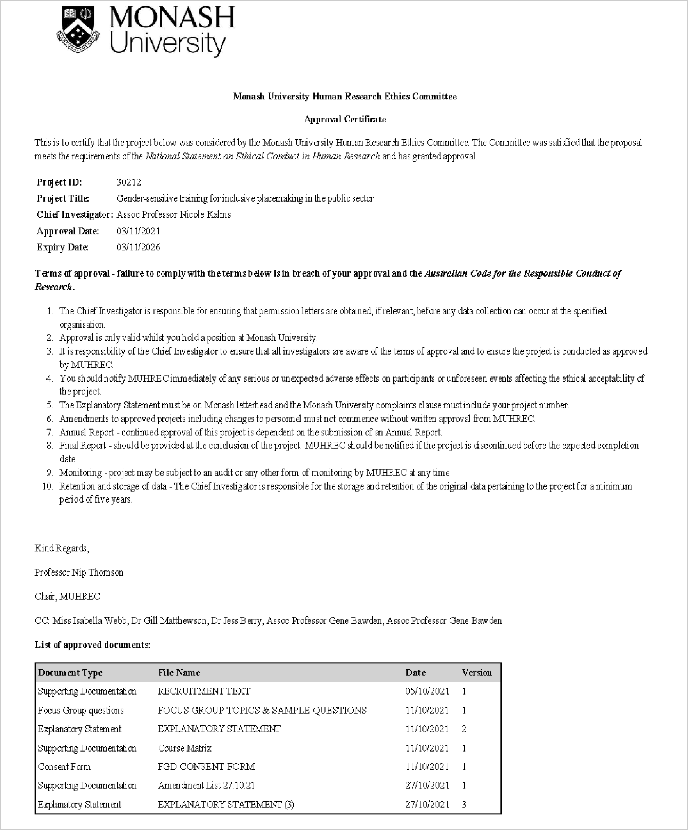

1. Kimberlé Crenshaw, Neil Gotanda, Gary Peller, Kendall Thomas, ed., *Critical Race Theory: The Key Writings that Formed the Movement* (New York: The New Press, 1995).